**1936 Worcester Redlining Map**

**Original Version**



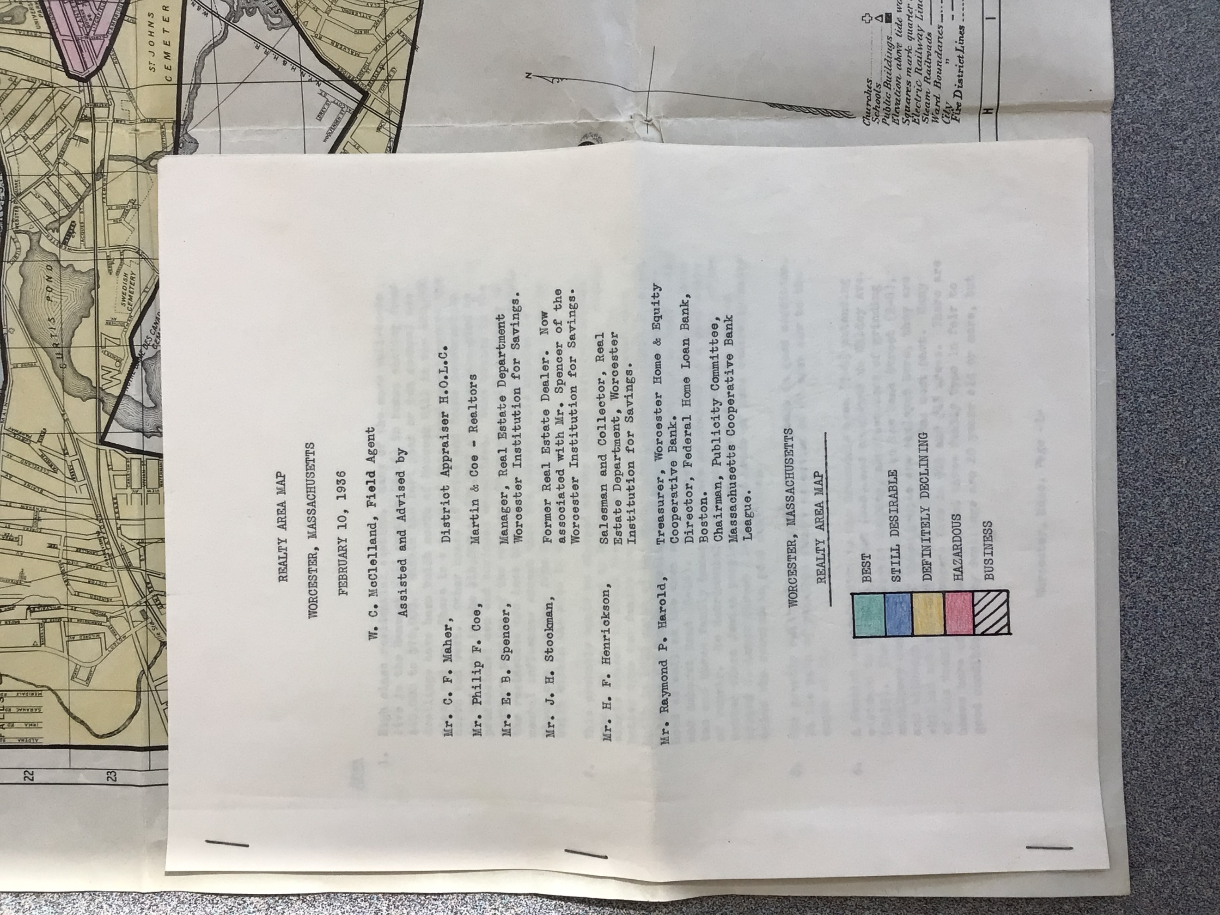

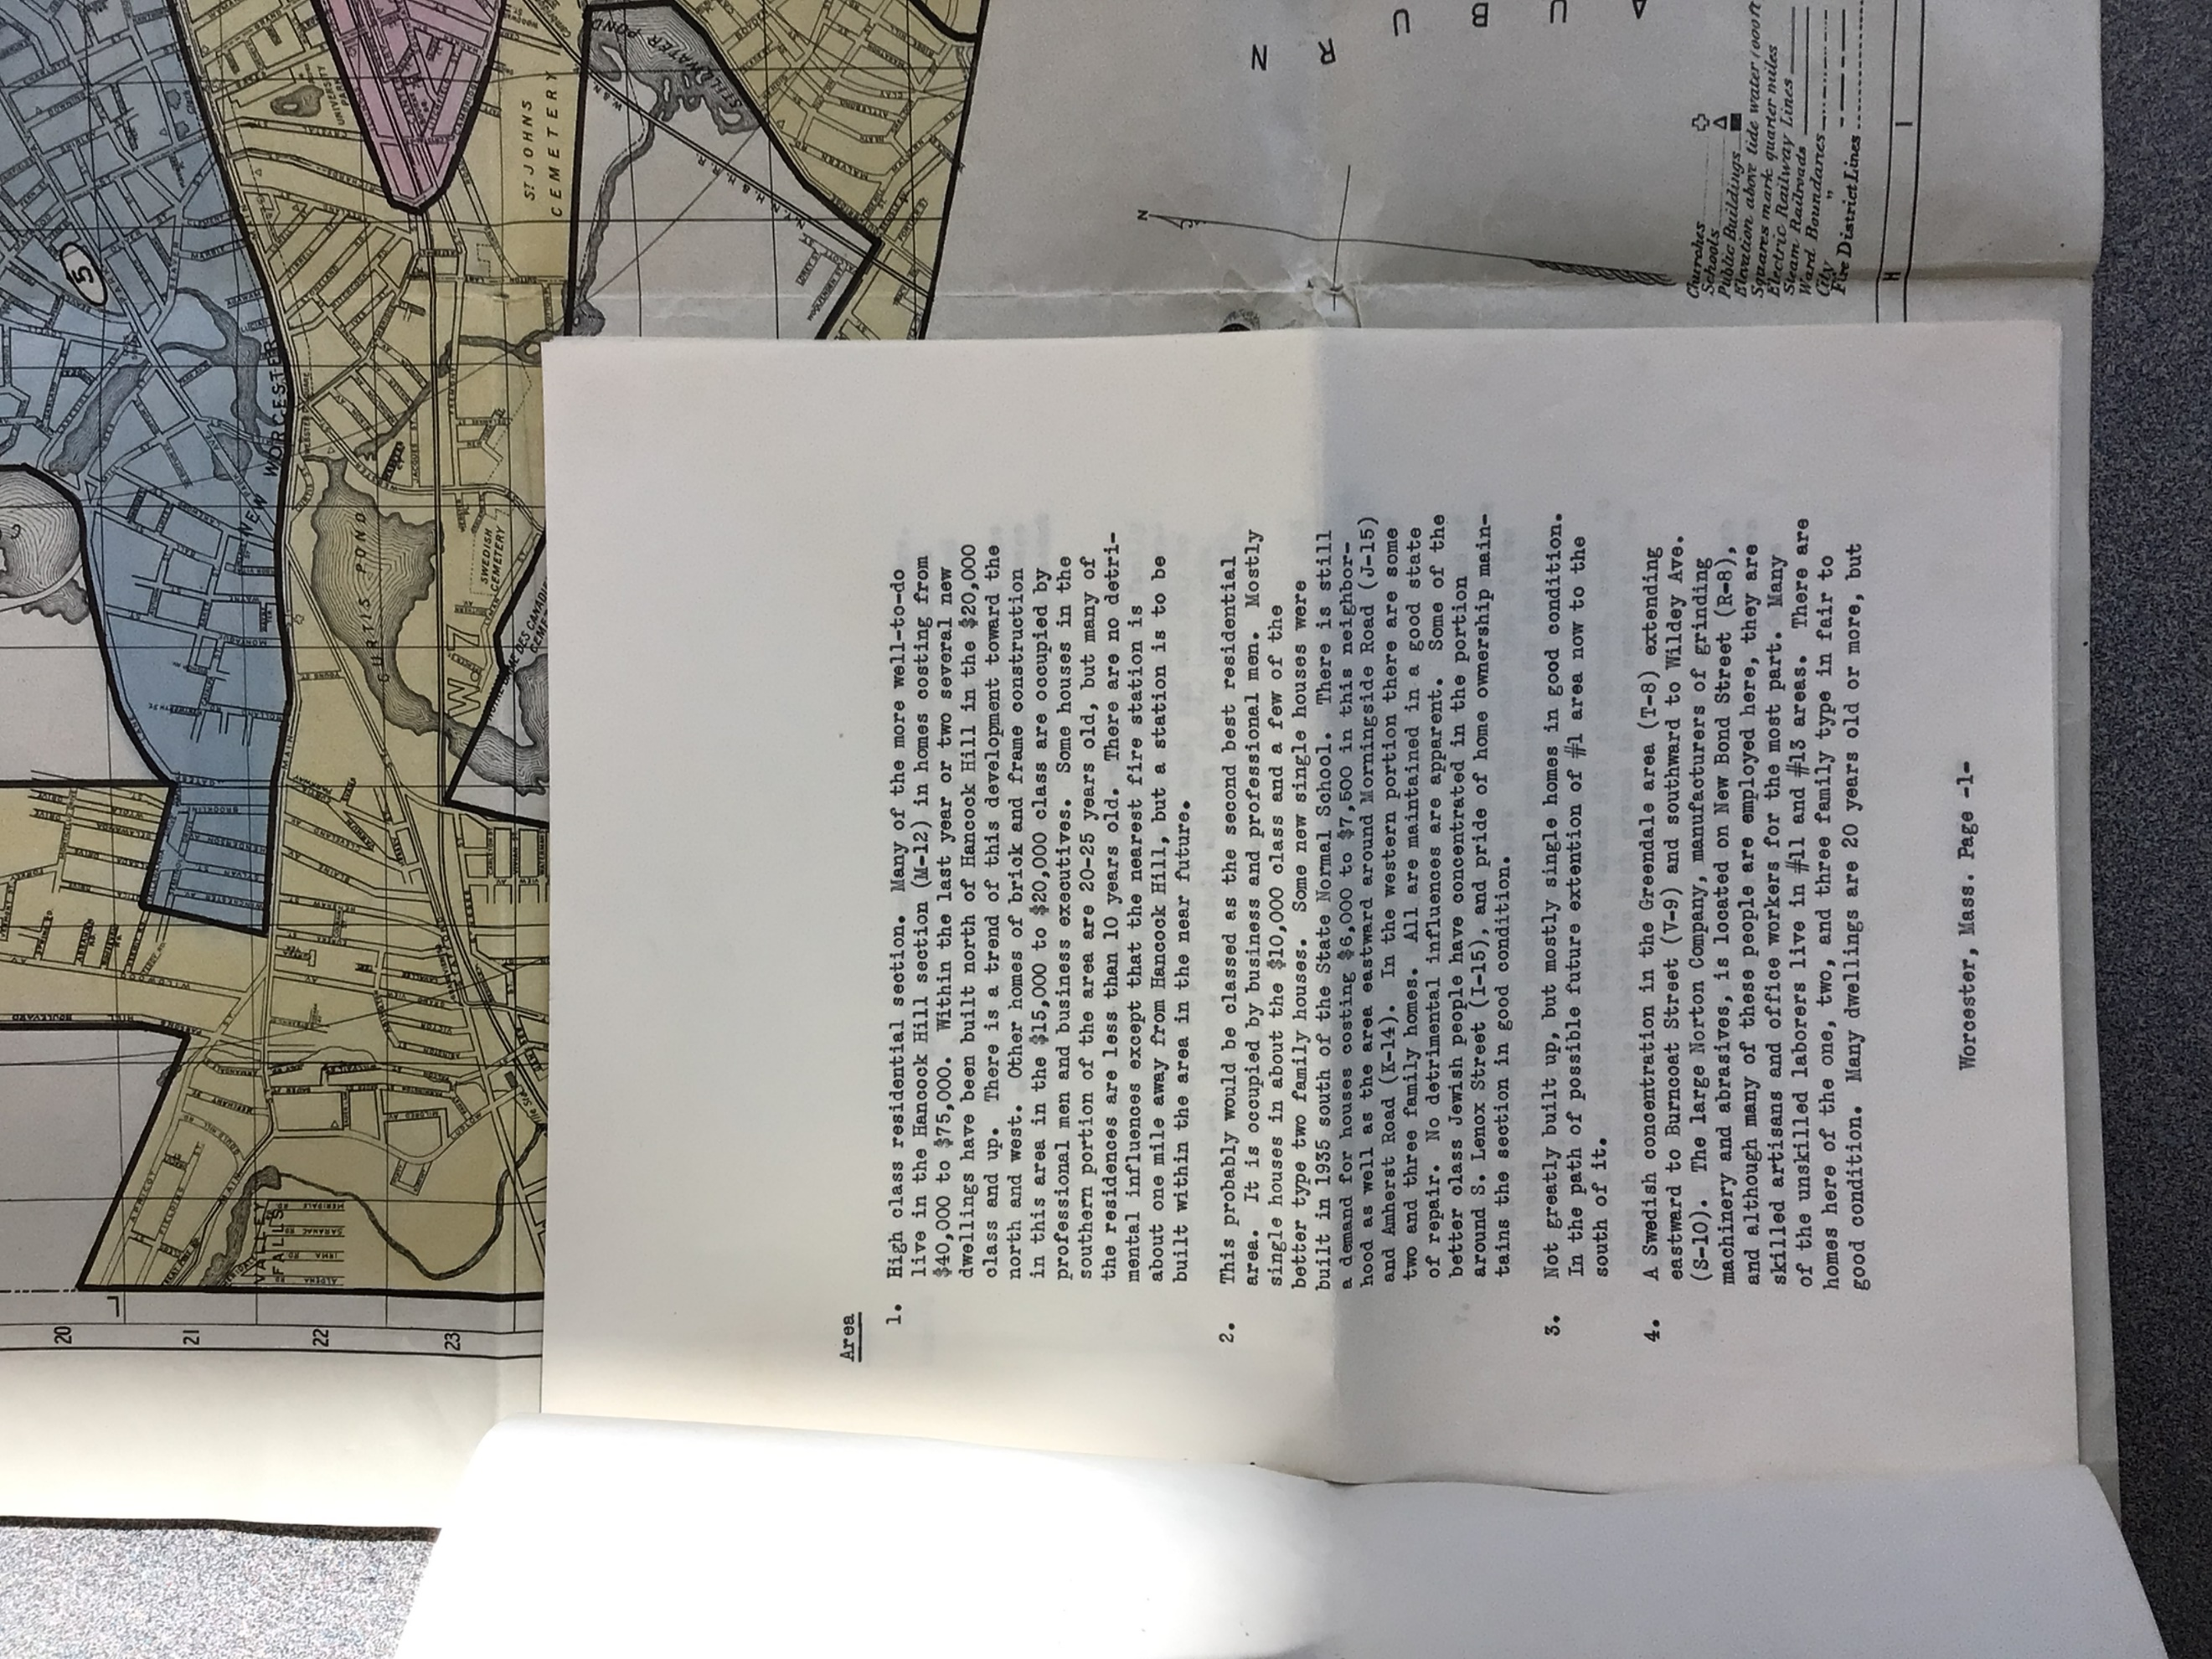

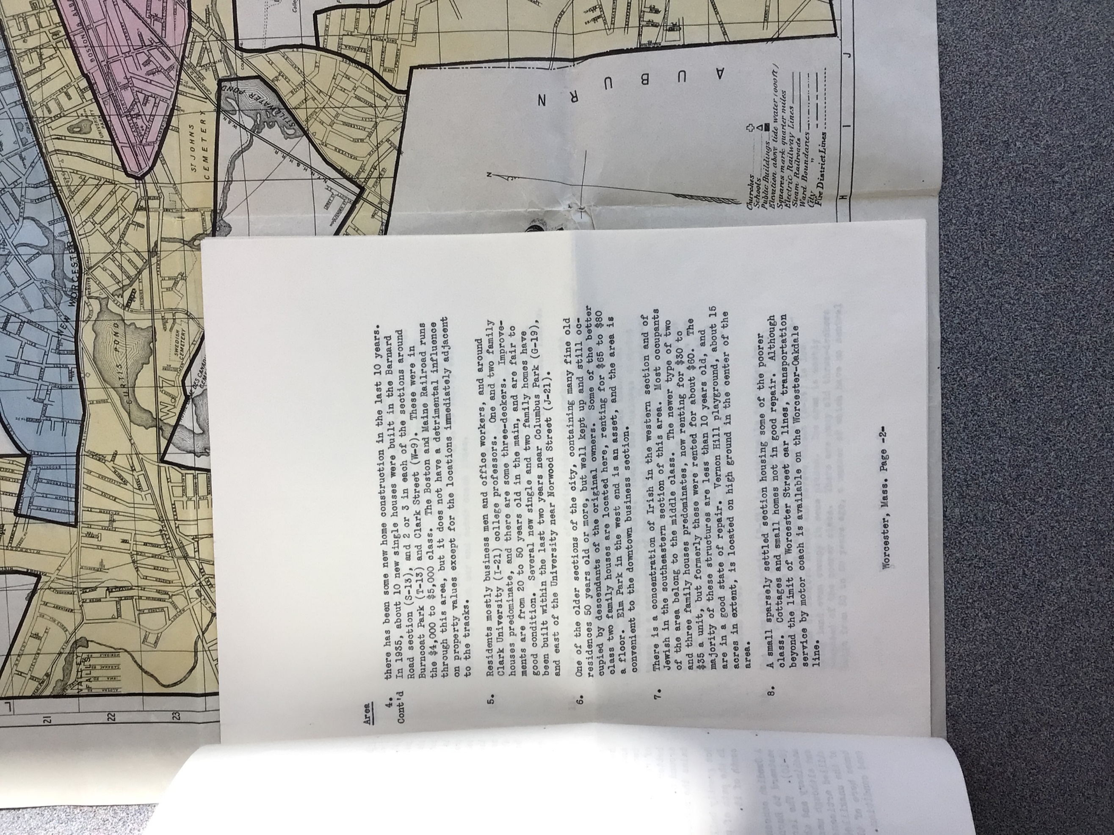

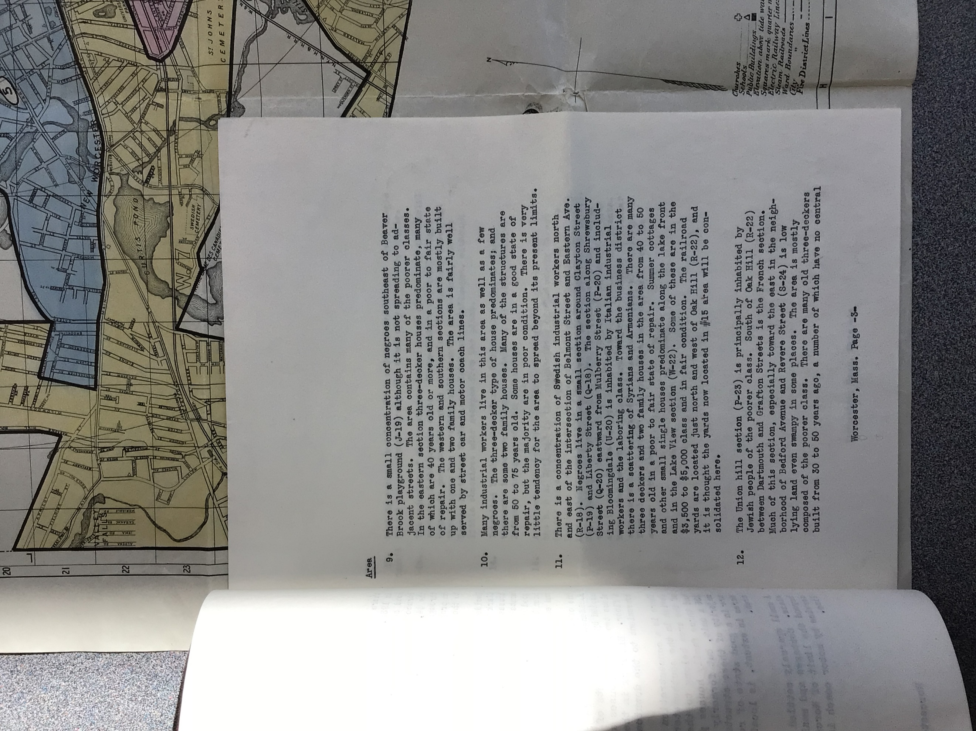

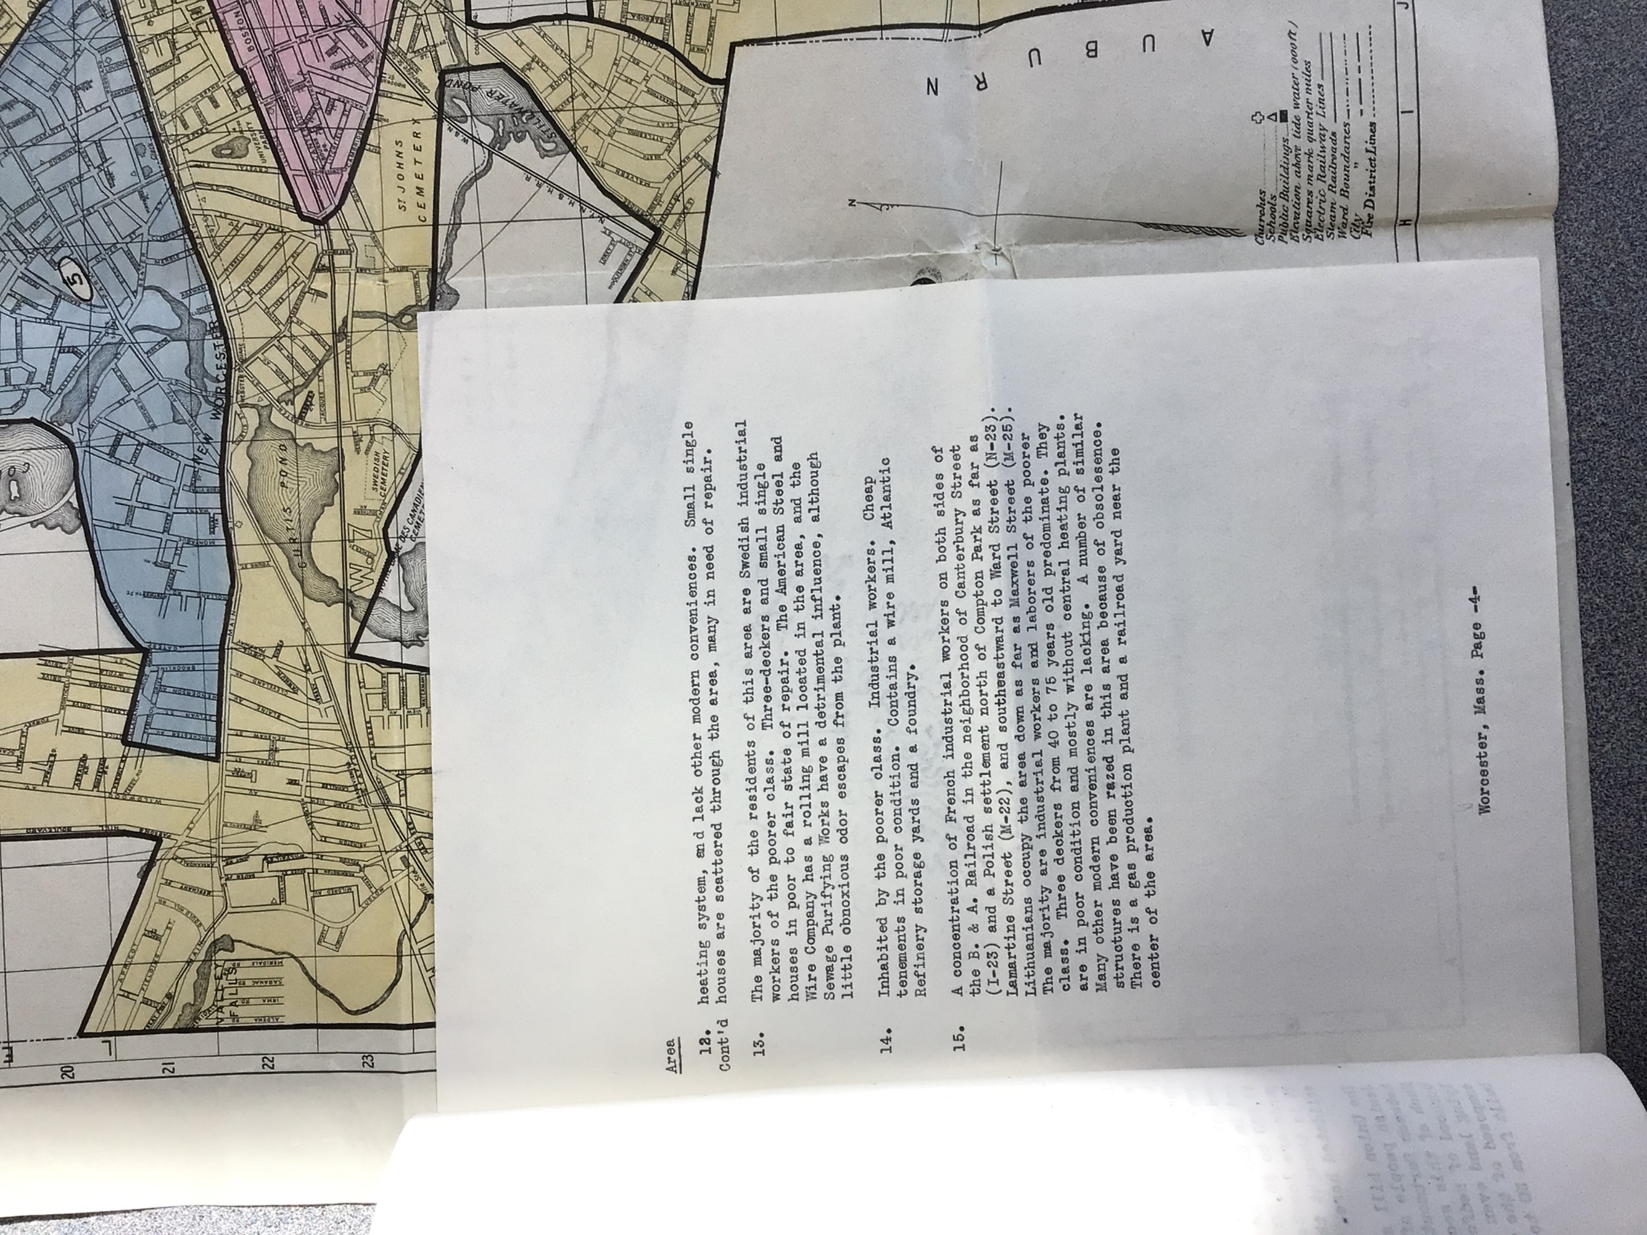

**Digital Version**

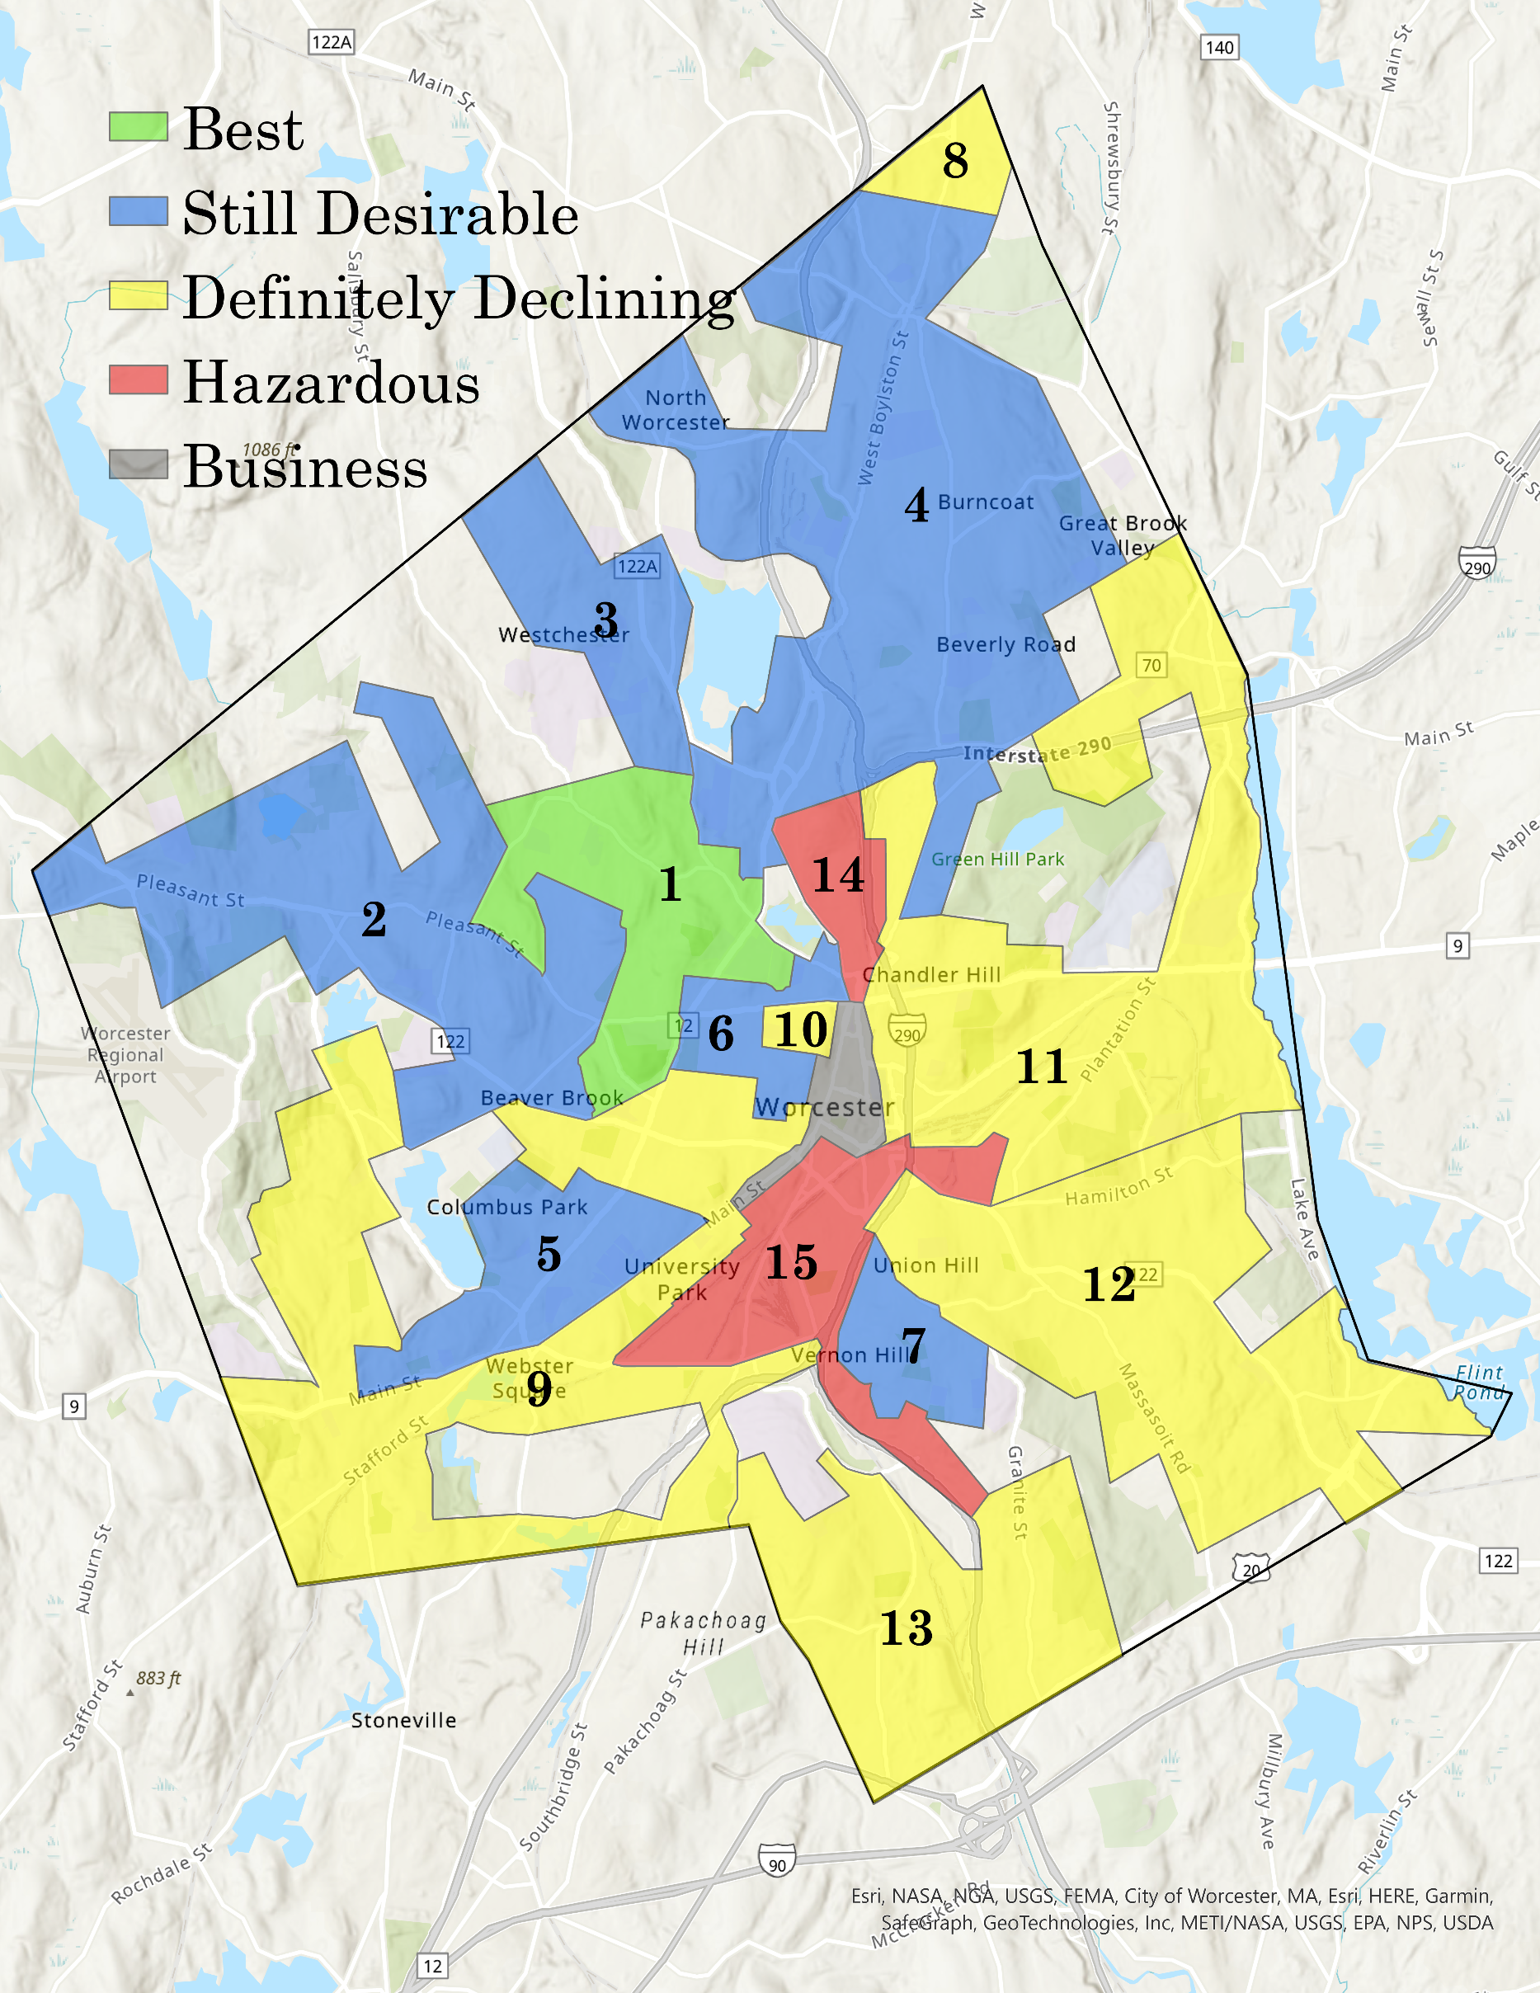

| **Zone** | **Classification** | **Description** |
| --- | --- | --- |
| 1 | A - Best | High class residential section. Many of the more well-to-do live in the Hill section (M-12) in homes costing from $40,000 to $75,000. Within the last year or two several new dwellings have been built north of Hancock Hill in the $20,000 class and up. There is a trend of this development toward the north and west. Other homes of brick and frame construction in this area in the $15,000 to $20,000 class are occupied by professional men and business executives. Some houses in the southern portion of the area are 20-25 years old, but many of the residences are less than 10 years old. There are no detrimental influences except that the nearest fire station is about one mile away from Hancock Hill, but a station is to be built within the area in the near future |
| 2 | B - Still Desirable | This probably would be classed as the second best residential area. It is occupied by business and professional men. Mostly single houses in about the $10,000 class and a few of the better type two family houses. Some new single houses were built in 1935 south of the State Normal School. There is still a demand for houses costing $6,000 to $7,500 in the neighborhood as well as the area eastward around Morningside (J-15) and Amherst Road (K-14). In the western portion there are some two and three family homes. All are maintained in a good state of repair. No detrimental influences are apparent. Some of the better class Jewish people are concentrated in the portion around S. Lenox Street (I-15), and pride of home ownership maintains the section in good condition. |
| 3 | B - Still Desirable | Not greatly built up, but mostly single homes in good condition. In the path of possible future extension of #1 area now to the south of it. |
| 4 | B - Still Desirable | A Swedish concentration in the Greendale area (T-8) extending eastward to Burncoat Street (V-9) and southward to Wildey ave. (S-10). The large Norton Company, manufacturers of grinding machinery and abrasives, is located on New Bond Street (R-8), and although many of these people are employed here, they are skilled artisans and office workers for the most part. Many of the unskilled laborers live in #11 and #13 areas. There are homes here of the one, two, and three family type in fair to good condition. Many dwellings are 20 years old or more, there has been some new home construction in the last 10 years. In 1935, about 10 new single houses were built in the Barnard Road section (S-13), and 2 or 3 in each of the sections around Burncoat Park (T-13) and Clark Street (W-9). These were in the $4,000 to $5,000 class. The Boston and Maine Railroad runs through this area, but it does not have a detrimental influence on property values except for the locations immediately adjacent to the tracks. |
| 5 | B - Still Desirable | Residents mostly business men and office workers, and around Clark University (I-21) college professors. One and two family houses predominate, and there are some three-deckers. Improvements are from 20 to 50 years old in the main, and fair to good condition. Several new single and two family homes have been built within the last two years near Columbus Park (G-19), and east of the University near Norwood Street (J-21). |
| 6 | B - Still Desirable | One of the older sections of the city, containing many fine old residences 50 years old or more, but well kept up and still occupied by descendants of the original owners. Some of the better class two family houses are located here, renting from $65 to $80 a floor. Elm Park in the west end is an asset, and the area is convenient to the downtown business section. |
| 7 | B - Still Desirable | There is a concentration of Irish in the western section and of Jewish in the southeastern section of this area. Most occupants of the area belong to the middle class. The newer type of two and three family houses predominates, now renting for $30 to $35 a unit, but formerly these were rented for about $60. The majority of these structures are less than 10 years old, and are in a good state of repair. Vernon Hill playground, about 15 acres in extent, is located on high ground in the center of the area. |
| 8 | C - Definitely Declining | A small sparsely settled section housing some of the poorer class. Cottages and small homes not in good repair. Although beyond the limit of Worcester Street car lines, transportation service by motor coach is available on the Worcester Oakdale line. |
| 9 | C - Definitely Declining | There is a small concentration of negroes southeast of Beaver Brook playground (J-19) although it is not spreading to adjacent streets. The area contains many of the poorer classes. In the eastern section three-decker houses predominate, many of which are 40 years old or more, and in a poor to fair state of repair. The western and southern sections are mostly built up with one and two family houses. The area is fairly well served by street car and motor coach lines. |
| 10 | C - Definitely Declining | Many industrial workers live in this area as well as a few negroes. The three-decker type of house predominates; and there are some two family houses. Many of the structures are from 50 to 75 years old. Some houses are in a good state of repair, but the majority are in poor condition. There is very little tendency for the area to spread beyond its present limits. |
| 11 | C - Definitely Declining | There is a concentration of Swedish industrial workers north and east of the intersection of Belmont Street and Eastern ave. (R-18). Negroes live in a small section around Clayton Street (P-19) and Liberty Street (Q-18). The section along Shrewsbury Street (Q-20) eastward from Mulberry Street (P-20) and including Bloomingdale (U-20) is inhabited by Italian industrial workers and the laboring class. Toward the business district there is a scattering of Syrians and Armenians. There are many three deckers and two family houses in the area from 40 to 50 years in a poor to fair state of repair. Summer cottages and other small single houses predominate along the lake front and in the Lake View section (W-22). Some of these are in the $3,500 to $5,000 class and in fair condition. The railroad yards are located just north and west of Oak Hill (R-22), and it is thought the yards now located in #15 area will be consolidated here. |
| 12 | C - Definitely Declining | The Union hill section (P-23) is principally inhabited by Jewish people of the poorer class. South of Oak Hill (R-22) between Dartmouth and Grafton Streets is the French section. Much of this section, especially toward the east in the neighborhood of Bedford Avenue and Revere Street (S-24) is low lying land even swampy in some places. The area is mostly composed of the poorer class. There are many old three-deckers built from 30 to 50 years ago, a number of which have no central heating system, and lack other modern conveniences. Small single houses are scattered through the area, many in need of repair. |
| 13 | C - Definitely Declining | The majority of the residents of this area are Swedish industrial workers of the poorer class. Three-deckers and small single houses in poor to fair state of repair. The American Steel and Wire Company has a rolling mill located in the area, and the Sewage Purifying Works have a detrimental influence, although little obnoxious odor escapes from the plant. |
| 14 | D - Hazardous | Inhabited by the poorer class. Industrial workers. Cheap tenements in poor condition. Contains a wire mill, Atlantic Refinery storage yards and a foundry. |
| 15 | D - Hazardous | A concentration of French industrial workers on both sides of the B. & A. Railroad in the neighborhood of Canterbury Street (I-23) and a Polish settlement north of Compton Park as far as Lamartine Street (M-22), and southeastward to Ward Street (N-23). Lithuanians occupy the area down as far as Maxwell Street (M-25). The majority are industrial workers and laborers of the poorer class. Three deckers from 40 to 75 years old predominate. They are in poor condition and mostly without central heating plants. Many other modern conveniences are lacking. A number of similar structures have been razed in this area because of obsolescence. There is a gas production plant and a railroad yard near the center of the area. |